## Design Documentation

Professional Practice in IT

## Table of Contents

Design Documentation 1

Table of Contents 2

Introduction to module 3

Introduction to project 3

TECHNOLOGIES USED 4

Google Cloud Platform 4

FileZilla 5

PuTTY 6

PHPMyAdmin 7

Photographic website 7

Conclusion 8

## Introduction to module

Professional Practice in IT is a module designed to have you work with a fellow student on a project. I (Kevin Flanagan) and Michael Mulholland decided to work together on project to be decided on at a future date. We will be setting up a meeting to discuss any ideas with had and then meet with our supervisor (Kevin O’Brien).

Part of this module we will be having different Skills Seminars throughout the coming weeks from different lectures/supervisors. These skill seminars will cover different topics over the following 13 weeks such as GitPod and GitHub that students can use to share and collaborate on their projects.

Presentations are to be held at the end of the project to showcase the work we have completed but unfortunately with the outbreak of COVID 19 it is unlikely these presentations will take place.

## Introduction to project

Began to research possible projects to select for this module.

GitHub created to support and share our project.

Had our first meeting about the project and did not decide on anything as we could not agree on what to create.

Need to decide:

* Set-up meeting with each other and supervisor (Kevin O’Brien)
* What we can build/work together on
* Sort out the git Repo so we can both use it
* Learn to use Milestones and Issues on GitHub

We met Kevin for the first time to discuss our project. We are having some problems with what to decide to create and discussed this with Kevin.

Kevin reassured us that we were panicking and that coming up with an idea for the project was going to be the most difficult part, once that was decided we could break up the work between us.

Towards the end of the week a Unity game is what we decided to create but there were still some problems with this as we were creating a unity game within another module. This created a difficult working environment between us as we could not see eye to eye on the game.

As we were deciding on our unity game, we started setting up Milestones and Issues on our GitHub repo.

**Lots of changes in this pass week.**

Michael and I (Kevin Flanagan) have worked things out over the project and have decided to go in a different direction. One of our earlier ideas was to build a website that could be sold to a client as a template and they could use it as they like.

After some discussion we have decided to create a Photographic website for a person to use to extend their business and reach a more clientele.

With this new change, we had to set up a new repo on GitHub and had to set up new milestones and issues to keep track of our website.

We discussed what parts we would each complete, Michael will complete the technical side of the project where I (Kevin) would take care of the documentation for the project.

Our supervisor seems to be happy with us back working together as that seem to be the main reason for this module and to see how we would get on working in a real workplace.

As Kevin said to us within one of our meetings earlier that once we have an idea everything will start coming together, with an idea of what we wanted to do we both got to work.

## TECHNOLOGIES USED

## Google Cloud Platform

Knowing what we want to create we both got down to work researching websites and different databases and ideas that would look good on our website.

From our research we started coming across different websites and different technologies to use, from storing images and setting up databases to having a working and consistent layout on the front end.

With research on hosting a server for our website three main options kept popping up in our searching:

* Google Cloud Platform
* Microsoft Azure
* AWS Amazons web services

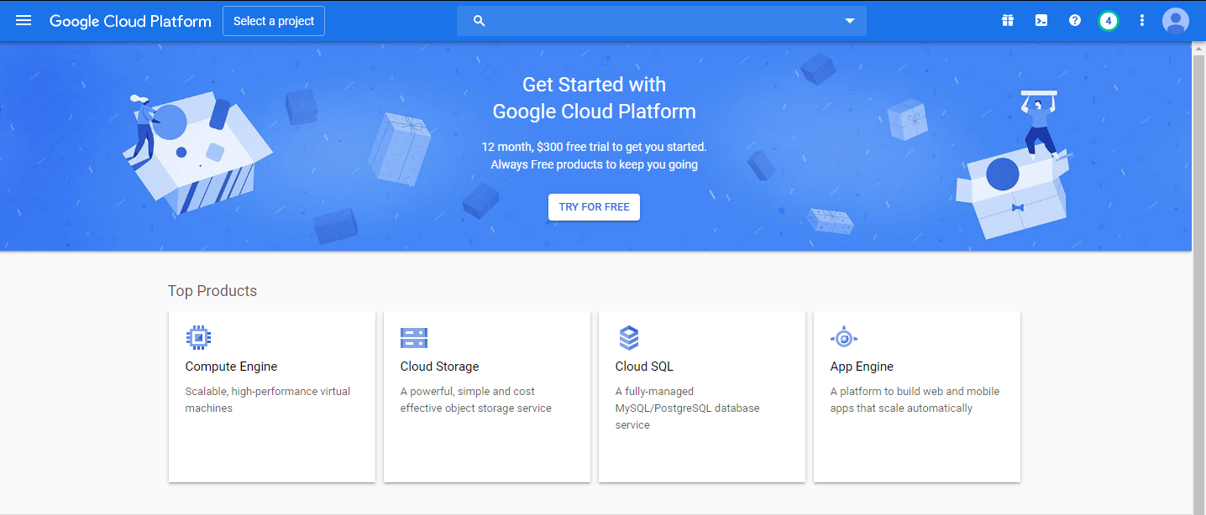We found that the best one to host our server for our client would be to use Google Cloud Platform.

<https://en.wikipedia.org/wiki/Google_Cloud_Platform>

Google Cloud Platform is part of a cloud computing services that end-users can use for data storage, data analytics and machine learning. Google Cloud Platform is made up of physical assets such as computers, hard drives, vitual resources like VM’s (Virtual Machine) and are located all over the world and are divided up into regions such as North America or Asia East. This takes the pressure off each region and helps with redundancy in cases of failures and can reduce latency if the servers are located near the clients.

We decided to use GCP (Google cloud Platform) because we had some free credit with it from our database module but also it is very user friendly, there are also so many tutorials online to help set up and host your own server. GCP seems to be the most popular one to use that is why would choose to use it.

Advantages:

* **Great Documentation –** loads of docs online to help set-up and maintain
* **Price –** very cheap to host on
* **Regions –** Loads of options to select a region new to the client for better service
* **Easy to integrate –** GCP is set up to be very easy to integrate with other google services

Disadvantages:

* **Support Fees –** support fees can be very expensive and get more expensive for the high packages
* **Complex Pricing –** easy to get unexpected costs

## FileZilla

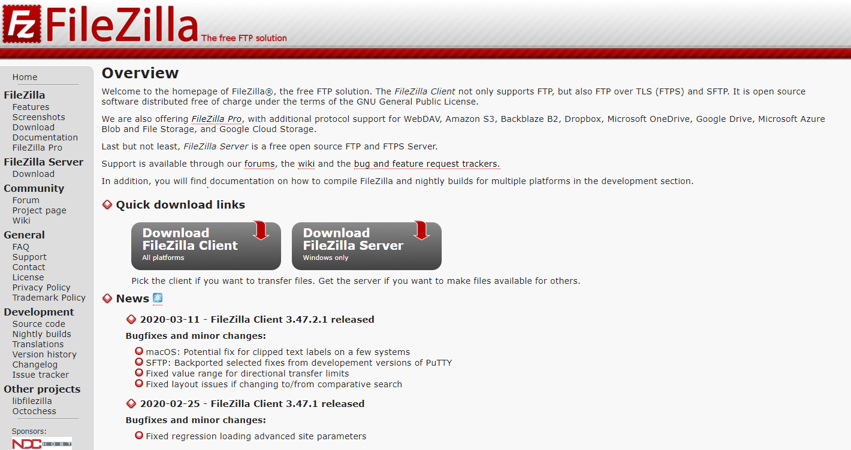After we decided to use Google Cloud Platform to host our server, we had to research how to host a website. Another program we had to use as it was always recommended to use together is FileZilla. FileZilla is used to transfer files from your local machine to the internet. Using FTP (File Transfer Protocol) and is built on a client-server model.

FileZilla is what was recommended to us by a lecture and we were told to look up PuTTY as well as we would need to use that also to help host our website.

Advantages:

* Good security
* Open source
* Cross-Platform support

Disadvantages:

* Slightly Dated at this stage
* Was designed for Linux

Wiki - <https://en.wikipedia.org/wiki/FileZilla>

Video - <https://www.youtube.com/watch?v=C6YmQYf3WBA>

Tutorial - <https://www.siteground.com/tutorials/filezilla/>

## PuTTY

PuTTY is a free and open source emulator used to transfer files onto the internet in a safe and secure way. It supports a few different network protocols such as SCP, SSH and Telnet and is a raw socket connection also. PuTTY is a secure way to provide user control over an SSH encryption key and protocols. It can also be used with local serial port connections and is also a network communication layer that supports IPv6.

PuTTY was created in 2000 and is make up of several components:

* PuTTY
* PSCP
* Plink
* pterm (Unix version only)

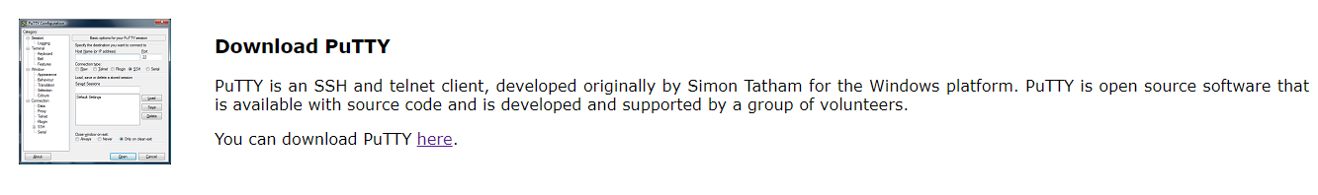Advantages:

* Free
* No admin rights needed
* Source Code available

Disadvantages:

* Cannot save Passwords
* Only one session at a time
* Lacks features (just a SSH client)

Wiki - <https://en.wikipedia.org/wiki/PuTTY>

Tutorial - <https://www.siteground.com/tutorials/ssh/putty/>

## PHPMyAdmin

PHPMyAdmin is an open source administration tool used with MySQL and MariaDB to build and maintain databases and very useful for web hosting services. It is a free tool written in PHP. Using this software lets you create, drop, delete, alter, import & export MySQL database tables.

Once you download phpMyAdmin you will be shown the following user interface:

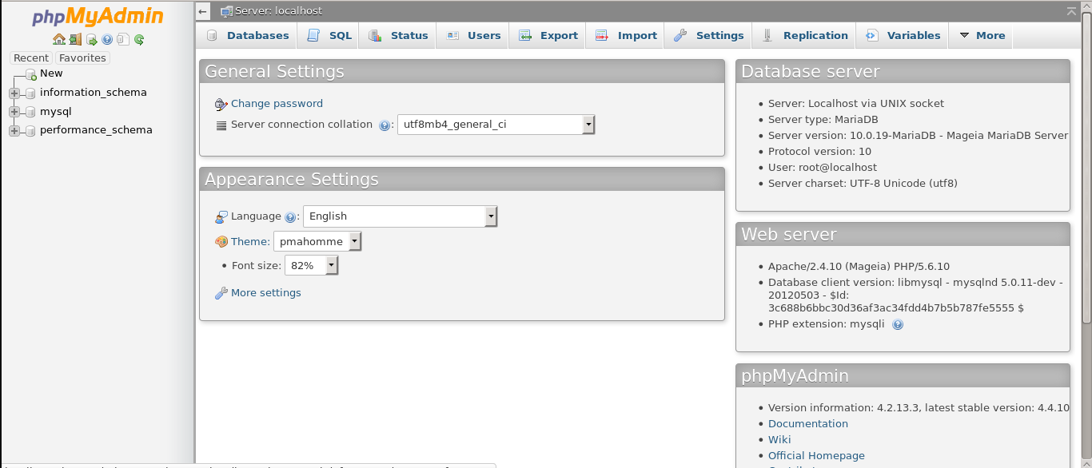

phpMyAdmin features an intuitive web interface which makes it easy for us to set up a database using MySQL, our client will be able to track his images for *his* clients and release them once he receives payment for the session/job. Passwords and other information will be stored here also and received when needed.

wiki - <https://en.wikipedia.org/wiki/PhpMyAdmin>

More details to follow in a report on LAMP! This report will go through each step needed to set up and host your own database.

## Photographic website

Luccchesi Photograph

Website set up with a myphpAdmin to store images and details, Michael has been doing great work with it and has been onto me about to set up some tests for it. We want our website to be easy to for the client to use so his clients will be able to contact him with jobs and questions on deals.

Main Website

* Home Page
* Portfolio Page
* Information Page – Sub pages on a drop-down menu - Pricing + FAQ
* The Experience / Reviews Page
* About Me Page
* Contact Page
* My Photos

The last page mentioned is going to be for a client to Register and to Login. This will also the admin of the site to restrict and control photographs. When a client has paid for their photos, they will be able to access them when they register and then login, they will be brought to their images on a personal page.

## Conclusion

With the end of this module drawing to a close, looking back at the discussions, planning, research and daily video calls to iron everything out I am happy with the conclusion and overall outcome of our project.

We created a fully functional website designed in collaboration with a client for his needs to reach a wider client base. This website was built to store the client’s images on a secure database that can be recalled and displayed when needed. A Login and Register has also been set for security, this will be how the admin of the website will be able to control the when his client’s receive their images after payments are received, samples and examples of these images can be shown to also before they buy them.

After a few hiccups from the start of the project where Michael and myself (Kevin) disagreed on what we should be create as a project. We did finally settle on building a website where Michael could build the website while I take care of the documentation side of the project. GitHub issues and milestones were setup to help track our work and progress as the weeks continued. Wiki pages and ReadMe also set-up.

## References

Google Cloud Platform - <https://en.wikipedia.org/wiki/Google_Cloud_Platform>

FileZilla - Wiki - <https://en.wikipedia.org/wiki/FileZilla>

Video - <https://www.youtube.com/watch?v=C6YmQYf3WBA>

Tutorial - <https://www.siteground.com/tutorials/filezilla/>

PuTTY - Wiki - <https://en.wikipedia.org/wiki/PuTTY>

Tutorial - <https://www.siteground.com/tutorials/ssh/putty/>

phpMyAdmin wiki - <https://en.wikipedia.org/wiki/PhpMyAdmin>